NORWICH HEAD
COMPETITOR INFORMATION
SATURDAY 24th FEBRUARY 2024
TRAILER AND CAR PARKING
Towing vehicles will be directed past the old NRC entrance on Whitlingham Lane (NR14 8TR) and take the next left hand turn which will lead to the Whitlingham boathouse, quayside and NRC. Only towing vehicles, cars carrying boats or those requiring disabled access will be allowed down this track to the trailer park area. The track is also an emergency access route to the Whitlingham Outdoor Adventure Centre (WOAC) and must be left clear for emergency vehicles. Disabled parking is available outside the boathouse.
All other cars need to be parked in the Pay and Display car parks located further along Whitlingham Lane – please see the NRC map for locations.
REGISTRATION
Race Control is located upstairs in the Clubhouse. Please report here from 08:00 for registration and race numbers. Crews will be provided with one empacher slot number in addition to two paper numbers – one for warm up kit and one for race kit. Please ensure that all payments and substitutions are submitted via BROE prior to registration. No numbers will be released until full payment has been received. Numbers for all divisions can be collected from 08:00.
A safety briefing will take place at 08:00 in the Clubroom for race marshals. Competitors are also welcome to attend.
BOATING
Boating Times – Crews will boat from the NRC quay heading. Please see the boating schedule for individual crew boating times. It is essential that crews adhere to the boating times to enable everyone to get to the start in good time. Marshals will be in the boating area – please heed their instructions. Penalties may be awarded to crews who are deemed to be deliberately delaying boating.
Boat Safety – Marshals may perform spot checks prior to launching and any boat that fails to meet the relevant BR safety standards will NOT be allowed to boat. Spot checks on heel restraints and bow balls may be carried out prior to boating. All coxes shall wear a lifejacket appropriate for either stern or bow-loaded positions and each boat will need to have heel restraints and bow balls appropriately fixed.
Clothing – Competitors can expect to be on the water for some time (2-2.25 hrs) so please ensure all competitors are attired for a range of different weather conditions on the day. Race marshals will prohibit any crew from racing if they are not suitably attired.
Footwear – A major limiting factor to getting crews on and off the water efficiently is dealing with footwear. Shoes and wellington boots must NOT be left on the quayside as they constitute a significant trip hazard. If you are not taking footwear in your boat please arrange for club colleagues to collect and return your footwear in a timely manner. Any footwear left on the quayside will be removed.
Oars and blades – Oars and blades must be stored at either end of the quayside, preferably on the scaffolding frames. They must NOT be stored on the quayside as they are a serious trip hazard. Any unattended blades on the quayside will be removed by the marshals.
No crews will be permitted to boat after 09:30 for Division 1, 12.30 for Division 2 and 14.00 for Division 3. Please ensure you are at the start, in your marshalling position at least 5 minutes before the start time for all divisions. Any crews causing a delay at the start will incur a 5 second time penalty for every minute of delay. Please give yourself enough time to reach the start area. There is plenty of open river downstream of the long course start to enable you to keep warm if you arrive early.
NAVIGATION
The river will NOT be closed during the day. Normal rules of navigation apply while paddling to the start and after the finish with crews required to keep to the starboard/bowside bank. All crews must use utmost caution at all times since this is a navigable waterway and you may encounter cruisers, craft and fishermen. Crews must therefore follow instructions provided by race marshals positioned along the course.
MARSHALLING
Short Course – Competitors will be marshalled in the area upstream of the short course start. You will be directed to paddle past the start and to your marshal position along the north bank of the river. You will marshal with your bows continuing to point upstream. Once racing is underway marshals will instruct each boat to turn their bows to face direction of racing and move along towards the start. Once you have passed the finish line you will be directed to continue round the corner before turning and then paddling under the railway bridge onto the ‘old cut’ (point 1) to head back to NRC. Please be aware that you will not be able to exit the old cut back onto the river Yare (point 3) until all racing crews have passed by.
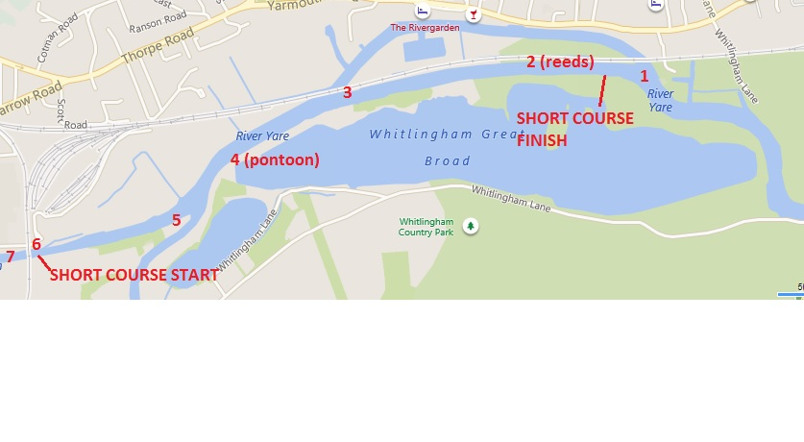
Long Course – Long course crews will marshal downstream from the start. Please follow the marshal’s instructions to direct you to your marshaling position. Long course crews with even numbers will marshal on the north bank of the river while those with odd numbers will marshal on the south bank (same side as timing team). Crews will be instructed to move to the start at 10 second intervals by the marshals. On passing the finish keep rowing towards NRC to enable following boats to complete the race.
RESULTS
All results will be available in the clubhouse as soon as possible after each division and will be uploaded to the NRC website later in the day www.norwichrowingclub.com. Pots will be presented in the clubroom as soon as possible after Division 3.
FACILITIES
Changing, shower and toilet facilities will be available at NRC from 08:00. Hot drinks, bacon rolls and cakes will be available all day.

