**WHITLINGHAM BOATHOUSES**

**BOATING AREA**

**FINISH**

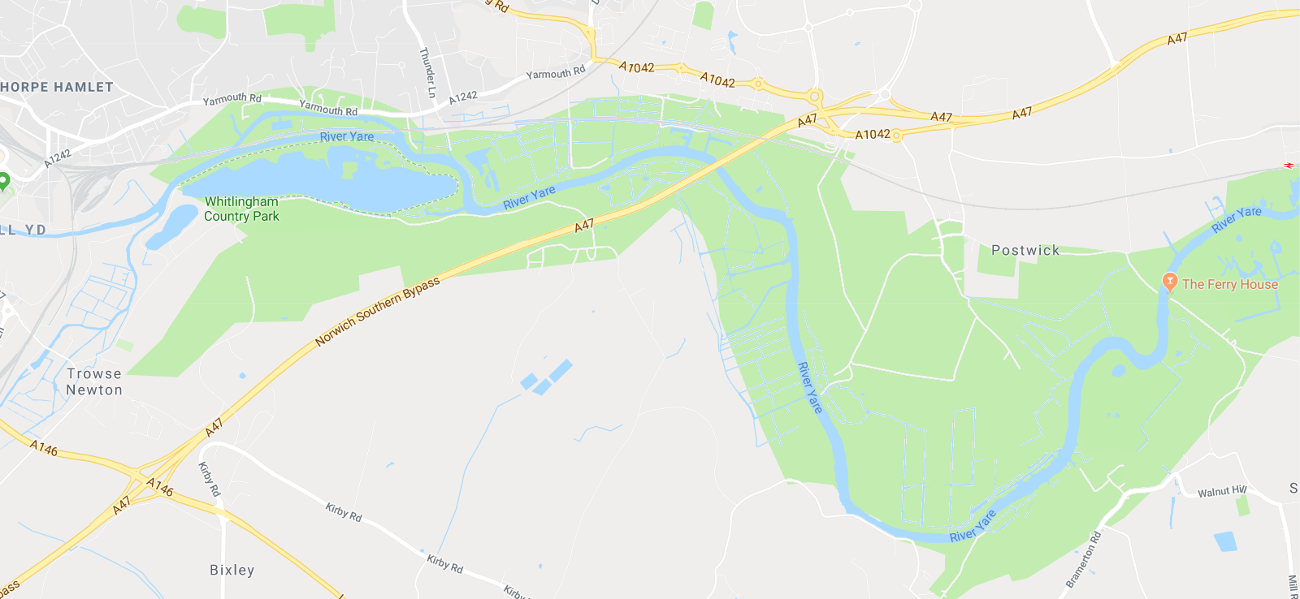

**NORWICH SBH AND NORFOLK SCULLS COURSE 2023**



500 m



**MARSHAL SHORT START**

**MARSHAL LONG START**

**ALTERNATIVE SHORT START**

**2200m**

**LONG START**

**5000m**

**SHORT**

**START**

**3000m**

**COURSE NOTES**

**LONG START** – EVEN NUMBERS ON NORTH BANK WITH BOWS UPSTREAM; ODD NUMBERS ON SOUTH BANK; LOWEST NUMBER CLOSEST TO THE START

**SHORT START** – POSTWICK ROAD BRIDGE; MARSHALL ON NORTH BANK WITH BOWS UPSTREAM; LOWEST NUMBER CLOSEST TO THE START

**ALTERNATIVE SHORT START** – THE 2200M OPTION WILL BE USED IN THE EVENT OF HIGH WINDS OR STRONG STREAM (RACE COMMITTEE DECISION)

**FINISH** – APPROX 150M DOWNSTREAM FROM THE RAILWAY BRIDGE ALLOWING YARE BC CREWS TO RETURN UNDER BRIDGE

**NOTE** – THESE COURSES RESULT IN A LONG START ROUND TRIP BEING APPROX 11Km AND SHORT COURSE APPROX 7Km