NORWICH HEAD RACE SATURDAY 25th February 2023.

EVENT SAFETY PLAN

Site Location
This event is organised by Norwich Rowing Club (NRC), Whitlingham BoatHouses (WBH), Whitlingham Lane, Trowse, Norwich, NR14 8TR Grid Reference TG 25031 07697.
What three words: ///grab.sleeps.future and the slipway is ///payer.oldest.third.

Introduction
The Event Safety Plan describes how competitors should act to keep themselves and others safe
so far as is reasonably practicable. All reference to ‘rowing’ includes sculling.

Everyone is expected to take responsibility for their own safety and the safety of others affected by
their activities. Everyone is expected to read, understand and follow the Event Safety Plans, Event
Safety Rules and guidance found in British Rowing (BR) publication RowSafe.

Competitors must understand they row at their own risk but providing they comply with plans and rules, make common sense decisions and conduct their own dynamic risk assessment then their safety should be maintained so far as is reasonably practicable.

River Yare
The Norwich Head race will be run in accordance with BR rules and BR guidance in RowSafe, with
safety of all water users the overall priority.

The 5km race starts at Riverscourt, Surlingham (near Church Lane) and finishes at Whitlingham Green.
The short course, just under 2km, race starts near Carrow Rail Bridge and finishes on the New Cut near Broadland Rowing Club.
The rowed section is tidal.

The Event Safety Plan comprises the following
• Event Responsibilities, Event General Arrangements, Guidance on Incidents
• Event Emergency Response Plan (separate document)
• Risk Assessment - Water and Land Safety (separate document)
• Competitor Information including course map, WBH site map and Notice to All Crews
& Local Rules (separate document covering navigation rules with penalties and/or
disqualification if not followed)

Race/Organising Officials
Race Committee Chairman - TBD
Race Secretary - Sarah Lister
Race Controller - Julian Ringer
Race Committee Umpires - See Officials Roster
Club Water Safety Advisor - Jonathan Myers
Emergency Coordinator - TBD
Marshalling Coordinator - TBD
Safety boat Coordinator - TBD
Registration/Entries Coordinator - Sarah Lister
Safeguarding and Welfare Officer - Sue Burrell

The term ‘Race Control’ contained within the plan refers to the designated room at WBH where
persons including the Race Secretary, Emergency Coordinator, Registration/Entries Coordinator
and any assistants may be based. Coordination of the race is carried out on the course by‘Start/Finish Officials’ using radios/mobile phones who will communicate directly with each other and any Course
Marshals. The Emergency Coordinator and assistant(s) will only assume control of the event if a
serious incident requiring implementation of the Event Emergency Response Plan occurs
whereupon the room will become the ‘Incident Control Centre’.

Event Responsibilities

Note the person carry out the role on the day may vary, depending on their availability. Some roles and responsibility maybe delegated after an in-depth brief.

Race Secretary
• Race planning and coordination
• Allocation of responsibilities detailed in Event Safety Plan
• Notify interested parties
• Ensure signage in accordance with Land Safety Risk Assessment
• On race day check NRC is ready and prepared for the race
• Nominate the designated emergency transport vehicle and driver(s)
Race Umpires/Race Committee
• Ensure racing conditions/course is as safe as can reasonably be expected
• Ensure racing is conducted safely, equitably, in accordance with local rules and in line with
BR rules.
• Update Race Officials/marshals on prevailing weather conditions on the course

Club Water Safety Advisor
• Prepare/review Event Safety Plan and Event Emergency Response Plan
• Oversee safety management of racing and related activities during the event so far as
reasonably practicable and provide advice as necessary
• Advise Race Committee and Emergency Coordinator on safety issues that affect the
conduct of racing – including any need to suspend racing
• Assist Race Committee with incident management in conjunction with Emergency
Coordinator
• Ensure competitors are reminded to submit a BR incident report if necessary

Emergency Coordinator
• Together with assistant(s) in the Incident Control Centre, coordinate the response to an
emergency requiring implementation of the Emergency Response Plan in line with the
actions listed within the plan
• Liaise with Race Committee, Club Water Safety Advisor and/or emergency services
• Maintain radios/mobile phones link with Scene Coordinator updating accordingly

Marshalling Coordinator/Umpire Commission
Brief ALL Marshals in the following
• Wear issued yellow ‘Marshal’ tabard to provide identification to competitors and
emergency services in case of serious incident
• Active intervention to prevent collision or incident affecting safety
• Use of radios/mobile phones
• Monitor competitors and colleagues for hypothermia
• Assistance to crews boating and landing.
• Encourage departing crews to boat promptly and make any adjustments on the water
• Encourage returning crews to promptly remove their boats from the landing area
Brief Start/Finish Marshals in the following
• Ensure Start/Finish marshals and assistants know their responsibilities
• Ensure Start/Finish marshals update Race officials and Boating Marshal of any issues that
prevent the next division/course from starting
• Minimise river congestion to reduce danger of collision so far as reasonably possible
Race Coordinator/Race Committee
• Take decisions, with advice as appropriate from Race Officials on safety issues that affect
the conduct of racing - including the need to suspend racing
• Control the disposition and use of safety boats
• Ensure that prior to the event race control assistants are briefed on their responsibilities
and the use of hand-held radios/mobile phones
• Confirm serviceability of race control equipment (loudhailers, finish horn, safety bags)
• Control the issue of and return of radios/mobile phones, loud hailers, tabards and safety bags to marshals
• Take the decision on disqualification of a crew if it is late for the start
• Monitor the weather conditions with updates from umpires as required (pto)
• Implement the Event Emergency Response Plan if required

Safety Boat Coordinator/Race Coordinator
• Ensure that prior to race the safety boat crews are briefed on the use of safety boats,
safety measures and use of radios/mobile phones
• Ensure safety boats are appropriately equipped
• Ensure safety boat cover is in place prior to the first boat going afloat
• Brief Race Officials of any problems on the river
Registration/Entries Coordinator
• Provide safety information to clubs and to the club’s website
• Register competitors on race day and provide race numbers

Event General Arrangements
Vehicles with Boat Trailers: Parking area adjacent to WBH (see site map) – marshals direct
along track and to suitable parking place. Emergency access to WBH and Whitlingham
Adventure must be maintained.

Access and Parking: At the entrance to NRC, marshals will direct boat transporting vehicles.
All other cars will be directed to Pay and Display car parks in the Whitlingham Country Park.
Boat Launching and Recovery: All crews will be informed of boating times. Once in the
launching/recovery area they are under the control of the Boating Marshal who will direct them
to the launch site, arrange for boat safety checks and give instructions to launch. Assistance
with launching/recovery will be given. Race Committee under the guidance of the Boat
Marshal reserves the right to disqualify any crew for late attendance or failure to meet any of
the race safety criteria.

Safety Equipment: The following safety equipment is provided: launches/safety boats,
lifejackets, buoyancy aids, throw lines, loud hailers, radios/mobile phones, whistles, air horns together with thermal blankets, first aid kits and cpr face masks on NRC launches, thermal blankets to marshals.
A defibrillator is based at WBH.

Capsize: In the event of capsize the occupant(s) should follow BR RowSafe guidance on
capsize and using the boat as buoyancy, proceed to the nearest bank. Course Marshals, on
bank or afloat, have sight coverage of the course. radios/mobile phones contact will be made to Start/Finish Marshals and Emergency Coordinator where necessary.

Any competitor that capsizes will not be allowed to start or continue racing and must return to WBH by the most appropriate means to maintain personal safety and prevent hypothermia.

First Aid: Anyone requiring first aid should be directed to the Medical Support situated at
WBH outside racing times. First aid equipment is available at WBH throughout the event.
Whilst racing is in progress, Medical Support with radios/mobile phones will be based on a designated launch at the race finish and will have access to limited first aid medical equipment.

A defibrillator is sited at WBH on the wall outside the main entrance (access code C159X).

The Medical Support will provide appropriate care and advise whether further treatment is
needed at hospital and if the casualty should be taken by family/friend/colleague or if an
emergency ambulance is required. Race officials should be updated by radios/mobile phones accordingly.

Communications – radios/mobile phones: Race officials and marshals will communicate with allocated radios/mobile phones on channel 16 and should be in possession of a mobile phone. Course officials/safety marshals will have loud hailers/flags/whistles to communicate with competitors/public.

Event Safety Rules: To assist with a safe event, a ‘Notice to all Crews & Local Rules’ is
provided to competitors setting out the requirement to adhere to usual navigational rules and
incident risk/penalties/disqualification if not followed.

Cancellation or Suspension of the Race: If an incident occurs or adverse weather
conditions make the event unsafe, the Race Committee including the Race Secretary, Club
Water Safety Advisor and other relevant persons, will at their discretion suspend or cancel the
race.

Incident Reporting to BR and NRC: Any incident must be reported to BR within 24 hours and to
NRC immediately. To complete an incident report to BR, use the proforma on the BR website. Once
submitted, it will have a unique identifying number. A copy will be sent to the Regional Water Safety
Advisor and NRC Water Safety Advisor.

An incident includes collision with anything, capsize, equipment failure, near miss or any other
incident whether on land or water which could affect safety and has caused or could have caused
injury or damage. Full details can be found in BR RowSafe. Collision with rowers from other clubs
must be reported by NRC members regardless of whether the other person intends to submit a
report. NRC members involved in an incident must also report it immediately to their relevant vice-
captain or coach. If suspected damage has occurred, the boat should be quarantined with red/white
tape kept in the boathouses they report all damaged equipment to Richard captain.norwichrc@gmail.com - directly if you can, or email repairs.nrc@gmail.com

Refreshments/Food Hygiene: Hot/cold drinks and food are available at WBH. Food will be
kept chilled as required. Uncooked meat will be kept sealed or separate from other foods.
Food handlers and kitchen staff will ensure appropriate hygiene measures are strictly
observed.

Changing facilities/showers/toilets: WBH has changing rooms with hot showers, toilets
and hand washing facilities. Additional portable site toilets are available.

Emergency Access Points
List of emergency access points and actions is contained in the Event Emergency Response Plan.
Diagram 1 shows the approximate area from satellite view of the course
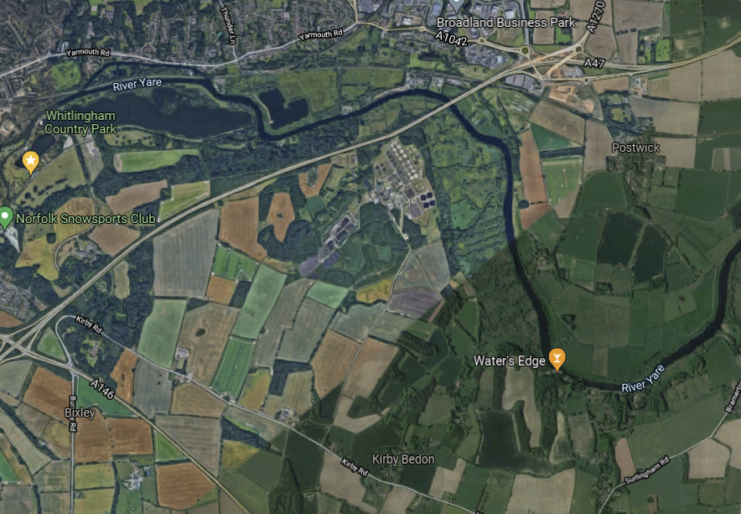
Diagram 2 shows the approximate area from a plan view of the course, with church lane the red dot.
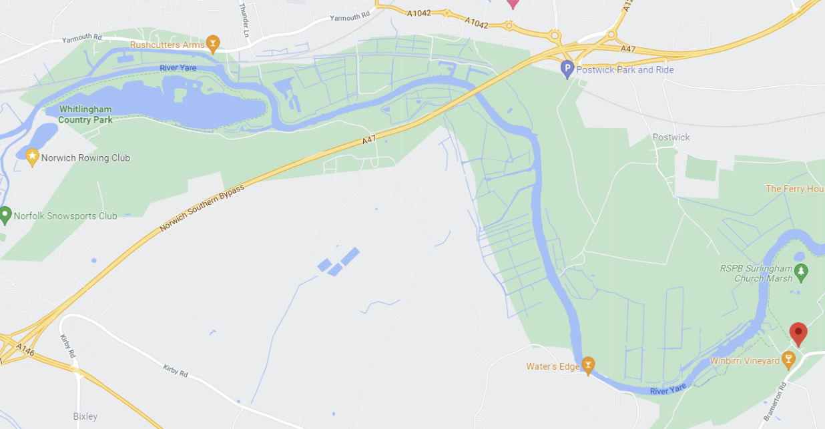

NRC Guidance on Incidents Requiring Implementation of Emergency

Response Plan
Any incident involving serious injury, potentially life changing or life-threatening injury which requires
the attendance of emergency services, will always require implementation of the Emergency
Response Plan.

Any incident with overwhelming numbers of people involved may require implementation of the
Emergency Response Plan.

Other incidents may require plan implementation to provide the appropriate response, resources
and resolution and thus prevent escalation to a life-threatening situation requiring the attendance of
emergency services. For example, multiple capsize with persons in the water may require a different
response in summer compared with low temperatures in winter and the high risk of hypothermia.
Scene Coordinator: In the event of such incident, the Race Committee and/or Emergency
Coordinator will instigate the Event Emergency Response Plan and the closest most suitable
Marshal or Race Official will take on the role of Scene Coordinator (refer to Emergency
Response Plan for guidance and actions).

Guidelines for Dealing with Initial Incident
• Stay calm, act swiftly and take control. Consider danger to yourself or danger to others? Find
someone to assist if necessary.
• Notify Start/Finish Marshals immediately.
• Contact emergency services if required giving precise location.
• Can incident be resolved promptly with available resources OR is it a serious incident
requiring implementation of the Event Emergency Response Plan. If implementation is
required, call Emergency Coordinator via radios/mobile phones without delay.
• Provide first aid if required. First aid kits are in WBH and in launch safety kits.
• Details on use of the Automated External Defibrillator (AED) sited on the wall outside WBH
entrance (access code C159X) are provided on WBH noticeboards and the Water Safety
Noticeboards. An AED is designed to be used by an untrained person, qualification is not
necessary. Open the lid and follow the audible instructions.
• Do not move casualty with serious injuries unless failure to do so would cause further risk to
life.
• Deal with any other persons and ensure they are adequately supervised.
• Contact family, friend, parent or carer of the casualty if necessary.
• Damage to any NRC boat, launch or equipment must be reported immediately to the Fleet
Manager at nrcrepairlog@gmail.com or inform squad vice-captain or coach. Boats must be
quarantined with red/white tape kept in the boathouse to prevent danger to others until
assessed and/or repaired.

NRC Water Safety Advisor - contact at safety.norwichrc@gmail.com

